InTheLine — Architecture & Project Plan
Oct 18, 2026 · @MST

Where InTheLine stands today
InTheLine is a working demo with no paying café yet; the next hard deadline is the GEF pitch on 6–8 Nov 2026, and the biggest live lead is NOT (4 branches). The product is built with Claude Code on Next.js + Postgres (local Docker today), shown in a FRIO-branded demo and a B Society-branded copy.
Area | State today
Cashier order board (tap items, daily numbers, QR, Preparing / Ready / Seen) | Built
Customer order page (live status, ready screen, "Got it", repeat reminders) | Built
Catch the Beans game, beans balance, coupons, leaderboard | Built
Owner dashboard (orders, avg wait, busiest hours, coupons) | Built
/design style guide, Arabic RTL + English, day/night mode | Built
FRIO logo, README, /admin panel to add cafés, rename to InTheLine | Next
Deploy to Vercel + hosted Postgres, real push test on phones | Next
Taste-test videos, tips, story-share discount, AI marketing helper | Pitched in the deck, not yet built
Pay from table, offline mode, POS link, lock-screen status, WhatsApp alert, all-branches view | Roadmap slide
Café pipeline
Café | Last step | What they want | Next
NOT (4 branches) | Visited 18 Oct | Price for 4 branches, customizations, tips, Apple Pay / card from table | Send a quote
B Society | Demo 17 Oct | Owner took your number | Follow up
FRIO | Not contacted | Demo brand only | Pitch with their own demo
Pricing on the table (per branch, EGP / month): Basic 1,500 · Pro 3,200 · Premium 5,800; setup 2,500 (waived yearly); founding offer = 30 days free Pro, then 25% off. At list price NOT on Pro is 12,800 / month for 4 branches; your ~25,000 figure needs a period attached (one-off setup, or a month, or a quarter) before the quote goes out.

Feature map
Build order follows money: finish the Basic core so it never misses an alert, then the Pro features NOT and B Society asked about (tips, pay from table, multi-branch), then the content features. The "New idea" rows are additions to discuss, not commitments.
Feature | Bundle | Status | Why it matters
Cashier order board + QR | Basic | Built | The core replacement for the pager
Customer order page + ready alert + repeat reminders | Basic | Built | The promise on slide 1
Catch the Beans game + leaderboard | Pro | Built | Makes the wait fun, drives return visits
Beans balance by phone + auto coupons | Pro | Built | Loyalty without a card
Owner dashboard + waiting-screen content | Pro | Built | Gives the owner a reason to log in
/admin panel: add café, branch, menu, brand, staff PINs | Internal | Next | Lets you onboard café #2 in under an hour
Real web push on Android + iPhone Home Screen | Basic | Next | Alerts while the phone is locked
Tips after pickup | Pro add-on | Pitched | Asked by NOT
Story-share discount (manual approval) | Pro | Pitched | Free reach on Instagram
Taste-test videos + manager approval | Premium | Pitched | Premium's main reason to exist
AI captions (Egyptian Arabic + English) + weekly summary | Pro | Pitched | Marked "coming next in Pro"
AI-made reels from approved videos | Premium | Pitched | Premium content engine
Pay from the table (Apple Pay, cards) | Add-on | Roadmap | Asked by NOT
WhatsApp backup alert | Basic | Roadmap | Covers iPhones with the page closed
All branches, one view | Pro | Roadmap | Needed for NOT's 4 branches
POS connection | Pro | Roadmap | No double typing at busy cafés
Offline mode beside the POS | Basic | Roadmap | Survives internet drops
Estimated wait ("about 6 min") from each branch's history | Basic | New idea | Fewer "is my order ready?" questions
Barista screen (kitchen display) separate from the cashier | Basic | New idea | Bar sees the queue; cashier keeps selling
"Now serving" TV board for the shop | Pro | New idea | Visible proof in the shop; sells itself
Thermal ticket printing with QR (ESC/POS) | Basic | New idea | For customers who won't scan the screen
One-tap rating after pickup, low scores go privately to the owner | Pro | New idea | Catches bad experiences before Google reviews
Birthday + referral beans | Pro | New idea | Two more reasons to come back
Broadcast offers to consented contacts (WhatsApp) | Premium | New idea | Turns the contact list into revenue
Prep time per barista and per item | Pro | New idea | Owner sees where the wait comes from
Platform super-admin: cafés, plans, invoices, usage | Internal | New idea | Billing 10+ cafés by hand won't scale
AI menu import from a photo of the menu | Internal | New idea | Cuts onboarding to minutes

Product structure
InTheLine is one Next.js project with four apps inside it, plus a public website to sell it. Each app has its own address and login, and all of them read the same database filtered by café, so a change in the owner dashboard shows up on the cashier and customer screens instantly.
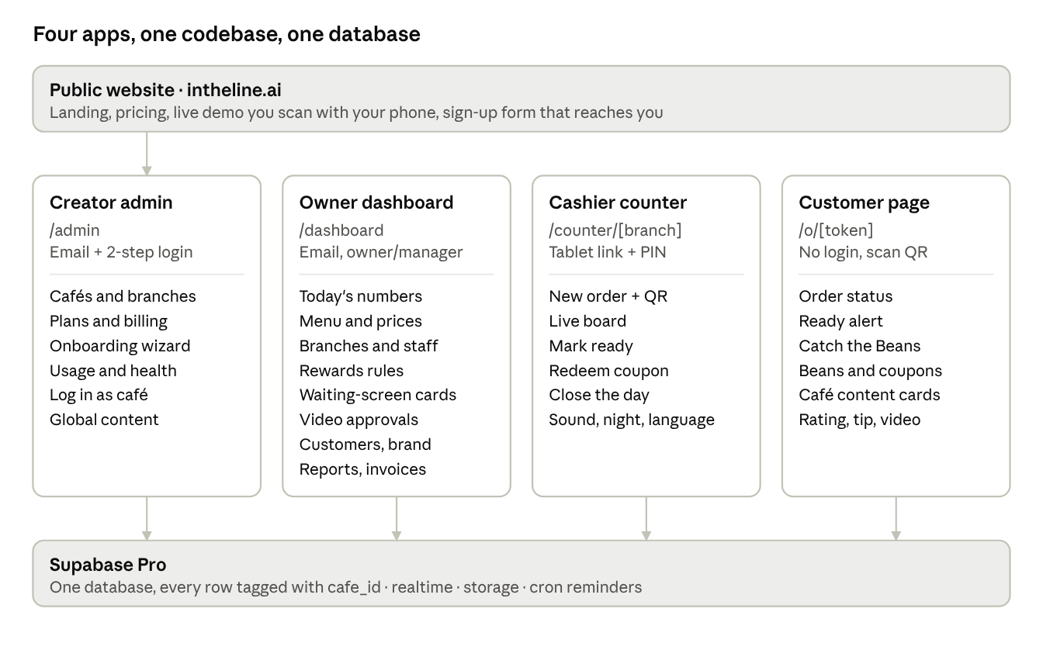
Product structure · website + 4 apps
Folder layout in the Next.js project (App Router):
app/
(site)/ public website: landing, pricing, demo, contact
admin/ creator admin — you only
dashboard/ café owners and managers
counter/[branch]/ cashier tablets
o/[token]/ customer order page
api/ push, payment webhooks, cron hooks
lib/ supabase client, auth, i18n, shared logic
components/ shared UI and design tokens
supabase/migrations/ tables, security rules, cron jobs
The security rule behind it: a user's role decides the app, and their cafe_id decides the data. Creator sees only plans, invoices and usage counts, never orders or customers; an owner sees only theirs; a cashier only their branch; a customer only the order whose token they scanned.

Workflows
Each role has one job: you sell and onboard, the owner configures and reads numbers, the cashier runs orders, the customer waits happily. A café should go from signed to live in one day.
You (creator) — from lead to live café
- Lead tries the live demo on the website or sees it in person.
- Send the quote; on yes, create the café in Creator admin and pick plan + branches.
- Onboarding wizard: branches, menu (typed or imported), logo and colors, bean rules, first content cards.
- Invite the owner by email; owner sets a password.
- Generate counter links and print QR stands per counter.
- Go-live day: open the counter on their tablet, run 3 test orders, train the cashiers in 10 minutes.
- Watch the first week's numbers in Usage & health; check in with the owner on day 7.
- Monthly: invoice, collect, and share a short results summary.
Café owner — setup once, then weekly
- Log in, check brand, menu and prices.
- Add branches and cashiers (name + PIN each).
- Set rewards: beans per order, reward threshold, coupon value and expiry.
- Edit the waiting-screen cards (offer, coming soon, own message).
- Daily: glance at Today (orders, average wait, busiest hour).
- Weekly: approve taste-test videos and story shares, download the report, look at returning customers.
Cashier — every order
- Start of shift: open the counter page, enter PIN.
- Tap items → Create order → number and QR appear (show on screen or print).
- Say: "Scan this, we'll ring you" — the card shows scanned once they do.
- Barista or cashier taps Mark ready → customer's phone rings.
- Order moves to Seen when they tap "Got it"; if it stays in Ready, call the number out.
- Redeem coupons by typing the code; close the day at end of shift.
Customer — every visit
- Scans the QR with the camera; the order page opens in the café's brand, no app.
- Taps to enable sound and notifications (and on iPhone, optionally Add to Home Screen).
- Watches status, plays Catch the Beans, reads the café's cards.
- Phone rings → "Got it — I'm coming" → shows the number at the counter.
- After pickup: one-tap rating, optional tip, taste-test video or story share.
- Enters phone number to keep beans; a coupon appears when the threshold is reached.

Selling it online
InTheLine is online-only by decision, and that is the pitch, not a weakness: nothing to buy, install, charge or lose, live in a day, and the owner sees every branch from their phone.
Why online is better for the café
Point | What to say
Nothing to install | "Open a link on any tablet you have. Live today."
No hardware | "No pagers to buy, charge, lose or replace."
Works for every customer | "It runs on the customer's own phone and data."
Never runs out | "Unlimited orders in the rush, not 20 pagers."
Always up to date | "New features every month, automatically."
Owner sees everything | "Your numbers on your phone, from anywhere, all branches."
Nothing lost | "A broken tablet loses nothing: swap it and log in."
Brings money back | "Coupons, contacts and videos keep customers returning."
Pay monthly | "No 15–20K up front; stop anytime."
Objections and answers
They say | You answer
"What if the internet drops?" | Same as your card machine: keep a 4G SIM or hotspot as backup; the number is printed and called out meanwhile.
"Customers won't scan." | The cashier says one line; the scan shows on the board; most customers already scan menus.
"Is our data safe?" | Each café's data is separated, backed up daily, and customer contacts are collected with consent.
"Pagers are a one-time cost." | A 20-pager kit costs about a year of Basic before a single pager is lost, and it never brings a customer back.
Channels to sell through
- Website with a live demo: "Scan this with your phone" — a demo order that rings 30 seconds later. The best sales tool you can build.
- Short videos (Instagram, TikTok): the blue ready screen and the bean game, in Egyptian Arabic.
- Direct visits + WhatsApp follow-up: demo on your phone, leave a one-pager, follow up in 48 hours.
- LinkedIn for chain owners and operations managers (NOT-type chains).
- Partners: POS resellers and café equipment suppliers who already visit cafés.
- Referrals: a free month for each café that brings another.
- Case study: after the first café's month, publish its real numbers (seen rate, returning customers).

Target architecture
Keep one Next.js codebase on Vercel and add services around it only where a café needs them; no microservices, no native app yet. Everything the screens do goes through the app, which checks the café and role before touching data.
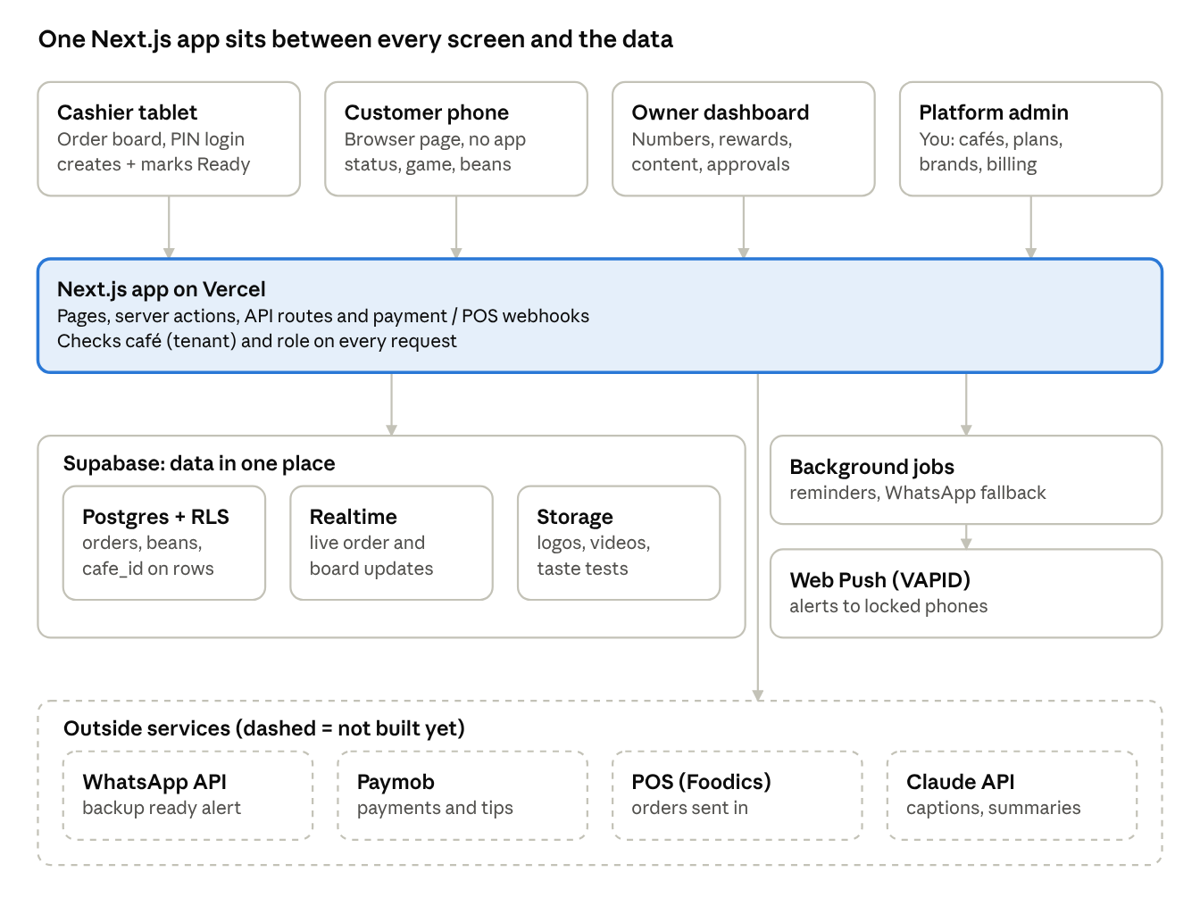
InTheLine target architecture · 4 layers
Read it top down: four screens call one app; the app stores data in Supabase and hands timed work (reminders, WhatsApp) to background jobs; the dashed services are added when a café pays for them.

Data model
Use one shared Postgres database where every row carries cafe_id (and branch_id where it applies), enforced by row-level security, so one bug can never show FRIO's orders to NOT. This "shared schema, tenant column" model is the cheapest to run and the easiest to report across for 10–500 cafés.
Table | Key columns | Notes
cafes | id, name, slug, brand colors, logo, plan, status | One row per customer business
branches | id, cafe_id, name, timezone, business_day_start | NOT = 1 café, 4 branches
staff | id, branch_id, name, role, pin_hash | PIN per cashier; never store the PIN itself
devices | id, branch_id, label, last_seen | A registered tablet per counter
menu_items | id, cafe_id, name_ar, name_en, category, active | Arabic + English names
orders | id, branch_id, daily_number, public_token, status, created_at, ready_at, seen_at, picked_up_at | public_token goes in the QR, never the daily number
order_items | order_id, menu_item_id, qty
order_events | order_id, type, at, by | Append-only history: created, scanned, ready, reminded, seen
customers | id, cafe_id, phone, name | Scoped per café, not shared across cafés
consents | customer_id, purpose, granted_at, source | Marketing contact, video use, WhatsApp
push_subscriptions | order_id or customer_id, endpoint, keys, platform | Web push targets
bean_ledger | customer_id, delta, reason, order_id, at | Balance = sum; never overwrite a balance
coupons | id, customer_id, code, value, expires_at, redeemed_at, branch_id
game_rounds | customer_id, order_id, score, started_at, ended_at | Server checks score vs. time played
content_cards | cafe_id, type, text_ar, text_en, active | Waiting-screen content
media_submissions | order_id, kind (video / story), url, status, reviewed_by | Taste tests and story shares
payments | order_id, kind (order / tip), amount, provider_ref, status | Filled by provider webhooks only
subscriptions | cafe_id, plan, branches, price, period, next_invoice | Your own billing
audit_log | actor, action, target, at | Who changed what
Two rules worth fixing in the code now: daily order numbers come from a per-branch counter that resets at business_day_start (so a 2 am order stays on "today"), and every write that can be retried (create order, mark ready, payment webhook) carries an idempotency key.

Real-time and alerts
The alert is the product, so it gets three independent paths: a live channel while the page is open, web push when the phone is locked, and WhatsApp when both fail. The server, not the phone, owns the reminder loop, so a closed tab never silently stops reminders.
Customer situation | Path that works | What to build
Page open, any phone | Live channel (WebSocket via Supabase Realtime or Ably) | Subscribe to order:{public_token}; on reconnect or visibilitychange, re-fetch status
Android, phone locked | Web push (VAPID) from Chrome | Ask for notification permission after the scan, not before
iPhone, page in Safari tab | Only while the tab is open; status refreshes on unlock | Tap-to-enable sound, Wake Lock to keep the screen on
iPhone, added to Home Screen (iOS 16.4+) | Web push works | The "Share, then Add to Home Screen" hint you already show
Page closed, phone number known | WhatsApp utility message | Send only if "Seen" hasn't happened N minutes after Ready
Order life cycle (what the server tracks)
- Created at the cashier → QR shown or printed.
- Scanned → customer subscribed to live updates and, if allowed, push.
- Ready → live event + push sent at once; reminder job scheduled.
- Reminded → every few minutes until "Got it", up to a cap (say 5).
- Seen → "Got it" tapped; board moves the order to Seen.
- Not seen after the cap → WhatsApp fallback (if consented), then flagged on the board.
- Picked up → tips, rating, taste test and beans unlock on the customer page.
Run the reminder loop as a scheduled background job (Inngest, Upstash QStash or Supabase cron + Edge Functions), not a setTimeout in a serverless function: Vercel functions stop when the request ends.

Payments, tips, POS and offline mode
InTheLine should never hold the café's money: each café connects its own payment-gateway account, and you only send the checkout and read the webhook. That keeps you out of payment-facilitator licensing and matches the deck's promise that tips go straight to the café's account.
- Gateway: Paymob is the obvious first choice. It holds the Central Bank of Egypt payments-facilitator licence and its Egyptian merchants can accept Apple Pay (source). Kashier and Geidea are alternatives if a café already uses them.
- Flow: order page → create payment intention with the café's keys → hosted checkout (Apple Pay or card) → webhook marks payments.status. Verify the webhook signature and treat it as the only source of truth.
- Tips: the same flow with kind = tip and no order total; report tips per branch and per day.
- Keys: store each café's gateway keys encrypted, readable only by server code.
- POS connection: start with Foodics, common with chains in the region. It already accepts third-party integrations that the owner authorises from the Foodics console (source). Build one adapter interface (createOrderFromPOS, onPOSOrderDone) so Odoo or others plug in later. Ask NOT which POS they run before promising this.
- Offline mode: phase it. First, recommend a 4G router as backup internet (cheapest, fixes most cases). Later, make the cashier board a PWA that queues orders in IndexedDB with idempotency keys and syncs when back. The customer's phone uses mobile data, so it keeps working either way.

Security, privacy and reliability
Three things can hurt the business quickly: another café's data leaking, beans being cheated into free drinks, and an alert that silently fails during a rush. Each has a cheap guard.
Area | Rule
Tenant isolation | Row-level security on every table by cafe_id; tests that try to read another café's order
Order links | QR holds a long random public_token; daily numbers are never enough to open an order
Staff access | PIN per cashier, hashed; device registration per counter; owner and platform admin use proper login
Game and beans | Server checks score against time played; cap of 150 beans per order enforced in the database; one round credited per order
Coupons | Single use, branch-checked at redeem, expiry stored
Personal data | Consent stored with time and purpose; customers can ask for deletion; Egypt's Personal Data Protection Law (No. 151 of 2020) applies to phone numbers and videos
Videos | Private storage, signed URLs, published only after manager approval
Reliability | Error tracking (Sentry), uptime check on the order page, daily database backups, a status line on the cashier board when live updates drop
Audit | Log every price, coupon, staff and settings change

Data privacy: the owner's data stays his
The promise to every café: "Your customers' personal data is locked with your key. Not even InTheLine can read it." Two options deliver it.
Option 3 — Locked with the owner's key (for every café)
- Customer names, phone numbers and videos are scrambled (encrypted) on the owner's own device before they are saved.
- The key comes from the owner's password or his phone's Face ID / fingerprint. Only he has it.
- The database keeps only scrambled text. You, Supabase, or anyone who steals the database sees nonsense.
- Only his dashboard can unscramble it and show the real names and numbers.
- Order numbers and items ("2 × latte") stay readable, because the cashier screen needs them and they are not personal.
- If he loses his key, nobody can recover the customer list — so at setup he saves a recovery code somewhere safe.
- Anything the system must read on its own (like sending WhatsApp messages automatically) is sent from his dashboard instead.
Option 4 — His own database (for chains, paid add-on)
- The café opens its own Supabase account and pays for it (about $25 a month).
- You install InTheLine's tables there once; the café gives you limited access only for setup and updates.
- InTheLine connects to his database whenever his café is open. All his data lives only there.
- You have no key at all, so you truly can't see anything.
- It costs him more and is more work for you (every update applied to each café's database), so it is sold as "Dedicated database" at a higher price.
 | Option 3: owner's key | Option 4: own database
Who it's for | Every café | Chains like NOT that ask for full control
What is protected | Customers' personal data | Everything
Extra cost for the café | None | Supabase bill, about $25 / month
Your effort | Built once for all | Setup and updates per café

Security layer: every concern in one place
Security is built as layers of locks, so if one fails the next one stops the attacker. Layers 2–4 are mostly built; the edge, monitoring, supply chain and legal layers must be finished before NOT goes live.
Layer | Concerns covered | Status | When
1. Edge | DDoS and traffic floods, bots, scanners; Vercel Firewall rules; rate limits on public endpoints (order page, PIN login, coupon redeem, game scores, push subscribe, sign-up form) | Basic only | Before NOT
2. Identity | Admin 2-step (done); owner 2-step encouraged, then required; owner counter login must ask for 2-step (bug being fixed); cashier PIN lockout; session expiry and sign-out everywhere | Mostly done | Before NOT
3. Permissions | Row-level security per café; limited app_runtime database user; branch-scoped cashier sessions (bug being fixed); support access only with owner approval, scoped to the person who asked (bug #11); anonymous access revoked on database functions (bug #4); creator's private notes moved to their own table (bug #5) | Done, fixes in progress | Now
4. Data protection | HTTPS everywhere; encryption at rest; owner vault for costs and customer data; hashed phones and PINs with HASH_PEPPER; secrets only in Vercel/Supabase env, rotated yearly or on any leak; private video storage with signed links | Done (videos to wire) | Ongoing
5. App hardening | Zod validation on every input; security headers (CSP, HSTS, frame and referrer rules); origin checks on server actions; unguessable order tokens; video uploads checked for type, size and length; no secrets or private data in client code | Partly | Before NOT
6. Fraud and abuse | Coupon code guessing; bean farming (150 cap, one round per order, score checks); expired coupons blocked (bug #7); notification spam; fake leads; disabled menu items rejected (bug #3) | Partly | Before NOT
7. Monitoring and response | Sentry error tracking; uptime checks; alerts on suspicious activity (failed PIN bursts, mass coupon tries, unusual traffic); audit log (done); cron log cleanup (bug #9); a written incident plan: who to call, how to lock a café, how to tell owners | Partly | Before NOT
8. Backups and recovery | Supabase daily backups; point-in-time restore add-on once paying cafés grow; a tested restore drill every quarter; Neon kept as fallback for a week after cutover | Not tested | Before NOT
9. Code supply chain | GitHub Dependabot and secret scanning; protected main branch; npm audit inside npm run check; seed scripts that refuse to run outside localhost (bug #8) | Missing | Now
10. Legal and compliance | Privacy policy and terms of service; data processing agreement with each café; consent records; data retention and deletion on request; Egypt's Personal Data Protection Law; who owns customer videos | Missing | Before NOT
11. AI gateway | Every AI call through one server-side gateway: keys on the server, usage limits per plan, cost tracking per café, vault data never sent to AI, prompt-injection checks on photos and customer text, output checks before anything is posted, logs without private data | Not built | Phase 2, before the first AI feature
12. Independent testing | A penetration test by an outside security team before chains go live; fix findings, then retest | Not done | Before NOT or right after
Before NOT goes live — security checklist
- ☐ Phase A bug fixes: seed guard, owner 2-step at counter, branch PINs, anonymous functions revoked, private notes moved, expired coupons, trial date
- ☐ Rate limits on every public endpoint and Vercel Firewall rules
- ☐ Security headers and video upload checks
- ☐ Sentry, uptime checks and suspicious-activity alerts
- ☐ Restore drill from a backup
- ☐ Dependabot, secret scanning, protected main branch
- ☐ Privacy policy, terms of service, café data agreement
- ☐ Incident plan written
- ☐ Penetration test booked

Taste-test video → customer's Instagram story
One recording does two jobs: the café gets a video for its own marketing, and the customer posts it to their Instagram story with the café visible. Websites can't add an @mention to a story automatically, so the café's name and handle are burned into the video itself.
- After pickup, the customer taps Record my first sip on the order page (15–30 seconds, front camera, no app).
- The video is recorded already branded: the café's logo, its @handle and a "Tasted at FRIO" sticker are drawn onto the camera image while recording.
- Two buttons: Send to the café (consent box, upload to the owner's Approvals) and Share to my Instagram story (the phone's share sheet opens Instagram with the video ready for Stories).
- The @handle is copied automatically with a hint: "Paste to tag @frio in your story".
- Reward: at first the owner or cashier checks the story and approves the discount (manual, as decided). Later, if the café connects its Instagram business account, story mentions arrive automatically and the coupon is issued without anyone checking.
Part | How | Limit
Recording | Browser camera + recorder, works on iPhone and Android | Keep it 15–30 s so files stay small
Branding | Logo and @handle drawn on each frame while recording | Heavier on old phones, so keep the overlay simple
Sharing | The phone's share sheet with the video file → Instagram → Stories | No automatic @mention sticker from a website; the burned-in handle and the copied text cover it
Verification | Manual approval now; automatic via the café's Instagram business account later (needs Meta app review) | Only works for cafés with a business or creator account
App Clip later | Native sharing straight into Instagram Stories with the café as a sticker | Needs the iPhone App Clip

Infrastructure and cost
Running cost stays small next to revenue: roughly $50–70 a month covers the first 10 cafés, against 32,000 EGP a month if all 10 are on Pro at list price. Figures below are approximate list prices; confirm before quoting them.
Recommendation: move to Supabase now instead of Neon. You already chose Supabase Pro for real clients, and it gives Postgres, row-level security, realtime channels, file storage for videos and cron in one place. Moving after go-live means a second migration.
Item | Choice | Approx. cost / month
App hosting | Vercel Pro | ~$20
Database, realtime, storage | Supabase Pro | $25 (your figure)
Background jobs (reminders) | Inngest or QStash free tier | $0 to start
Error tracking | Sentry free tier | $0 to start
Domain | intheline.ai or similar | yearly fee, varies by extension
WhatsApp alerts | Meta Cloud API, per message | only when the fallback fires
Payments | Paid by the café to its gateway | $0 to you
AI captions and summaries | Claude API, per use | a few dollars at pilot volume
Environments: local (Docker Postgres) → preview (a Vercel preview per pull request on a Supabase branch) → production. Never test on a café's live data; keep a demo café (FRIO) in production for sales demos.

Project plan
The next three weeks are about one thing: a deployed, reliable pilot you can demo live at GEF on Nov 6, 2026 and install at NOT right after. Each later phase starts only when its gate is met; the dates past GEF are targets to adjust, not promises.
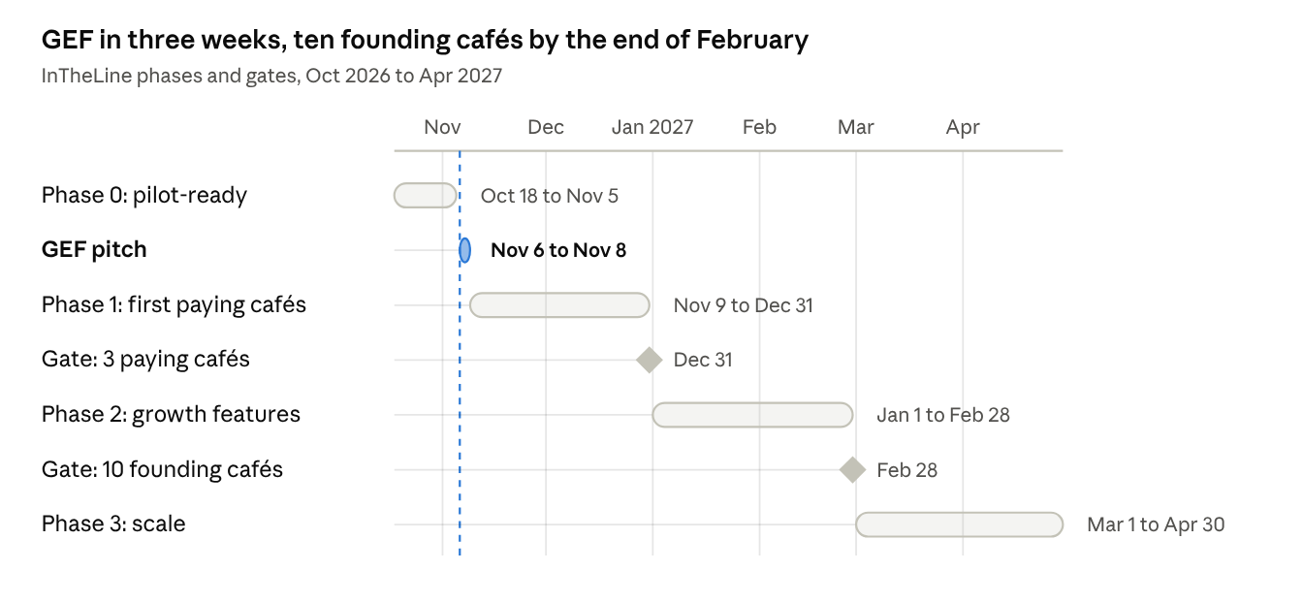
Roadmap · 4 phases, 2 gates
Phase | What ships | Gate to move on
0 · Pilot-ready | Deploy on the real domain, Supabase, /admin, real push on phones, reminder job, NOT quote, GEF demo + business card | Live demo works on any phone at GEF
1 · First paying cafés | NOT install (4 branches), all-branches view, WhatsApp fallback, tips + pay from table if NOT signs, onboarding checklist | 3 cafés paying
2 · Growth features | Taste-test videos, AI captions + weekly summary, POS link, estimated wait, barista screen, super-admin billing | 10 founding cafés
3 · Scale | Self-serve onboarding, AI menu import, offline PWA, TV board, Premium reels | Set after Phase 2
Next plan: iPhone App Clip (Phase 2, after GEF and NOT go-live)
The App Clip turns an iPhone into a real pager with no install: the same QR opens an App Clip card on iPhone and the website on Android.
- What it adds on iPhone: lock-screen notifications without a permission prompt (8 hours), order status live on the lock screen (Live Activity), a custom buzzer sound up to 30 seconds per notification, strong vibration while open, later Apple Pay tips and Sign in with Apple.
- Limits: silent mode mutes the sound (vibration still works); a small parent app must exist on the App Store.
- Needs: Apple Developer account ($99/year, enroll early), a Mac with Xcode (friend's MacBook), the iPhone in Developer Mode, Apple push key, a domain file linking intheline.ai/o/ to the App Clip.
- First step: a half-day prototype session on the friend's Mac — Claude Code builds the App Clip, it's installed on the iPhone, a Local Experience maps the QR link to it, the cashier runs on the laptop, and the Ready buzzer is tested on the locked iPhone.
- Then: 3–5 weeks part-time to a real release (App Store review, per-café cards, the web game inside).
- ☐ Enroll in the Apple Developer Program
- ☐ Book the session with the friend's Mac; install Xcode beforehand
- ☐ Write the Claude Code prompt for the App Clip prototype
Phase 0 checklist (now → GEF)
- ☐ Move database to Supabase; add cafe_id + row-level security on every table
- ☐ Rename to InTheLine everywhere, add FRIO logo, write README and CLAUDE.md
- ☐ Build /admin: add café, branches, menu, brand colors, staff PINs
- ☐ Buy the domain and deploy to Vercel production
- ☐ Web push working on Android and on an iPhone Home Screen app
- ☐ Server-side reminder job with a cap and "stop on Seen"
- ☐ Sentry + uptime check on the order page
- ☐ Send NOT the 4-branch quote; follow up with B Society
- ☐ GEF: founder portfolio, website, business card, a QR demo visitors can scan themselves

Working method
You are one founder with a 9–5 job, so the method has to be light: one board, one-week sprints, and a written spec before every Claude Code session. The spec is what keeps a fast AI coder from drifting.
The loop each week
- Pick 3–5 cards from the backlog for the week, ranked by "does a café pay for this?"
- For each card write a short spec in the repo (/specs/<feature>.md): user story, screens, data changes, done checks.
- Build on a branch with Claude Code; it reads CLAUDE.md (stack, folder rules, tenant rule, naming) and the spec.
- Open a pull request → Vercel preview → test on a real Android and a real iPhone.
- Merge, deploy, and write one line in a changelog the cafés can see ("Updates: every month" is a promise on your comparison slide).
Board columns: Backlog · This week · Doing · Testing on phones · Done. GitHub Projects keeps it next to the code; Notion works if you prefer.
Definition of done: works in Arabic and English, works on Android and iPhone, respects cafe_id, has a test for the main path, and the demo café still works.
What to measure
KPI | What it tells you | Target to aim for
Scan rate (orders scanned / orders created) | Do customers adopt it? | Set after the first pilot week
Seen rate (Got it / Ready) | Does the alert work? | As close to 100% as possible
Ready → Seen time | Do customers come quickly? | Track the median per branch
Game play rate | Is the wait engaging? | Set after pilot
Coupon redemption + repeat visits by phone | Does Pro bring them back? | The number you sell Pro with
Cafés live, branches, MRR, churn | Is the business growing? | 10 founding cafés
The pilot targets are blank on purpose: set them from the first week of real data, not guesses.

Risks and decisions
The biggest risk is not technical: it is iPhone customers missing an alert in a busy shop, which would make a café go back to pagers. Fix that path first.
Risk | Effect | Mitigation
iPhone customer closes the page | Missed alert, crowd at the counter | Board shows "not seen", WhatsApp fallback, Home Screen prompt
Customers don't scan | No data, no loyalty | Cashier script, QR stand at eye level, beans for scanning, printed ticket
Café internet drops | Board stops | 4G router backup now, offline PWA later
Scope too wide for one person | Nothing ships well | Ship Basic + Pro core first; Premium waits for a paying request
Payment money passes through you | Licensing and trust problems | Café's own gateway account only
Bean cheating | Free drinks, angry owner | Server-side score checks and caps
Personal data complaint | Legal and reputation hit | Stored consent, deletion on request
Price vs. a one-off pager purchase | Owner says "pagers are cheaper" | Show yearly Basic = pager kit price, before any pager is lost
Decisions to make this week
- ☐ Supabase now or after the first café (recommended: now)
- ☐ NOT quote: Pro for 4 branches at founding price, and what the ~25,000 EGP covers
- ☐ Tips + pay from table: add-on price, and which gateway NOT already uses
- ☐ Which POS NOT runs
- ☐ Domain name and buying it before GEF
- ☐ Legal entity and invoicing for InTheLine, since it sits outside AOM Tech

What to study
Eight topics, in this order, each tied to a piece of InTheLine you will build. One topic a week fits your weekly learning plan: read on weekdays, build the practice task on the weekend.
Week | Topic | Why InTheLine needs it | Practice task
1 | Multi-tenant SaaS + Postgres row-level security | Keep each café's data separate | Add RLS on orders; write a test that fails when café A reads café B
2 | Realtime (WebSockets, pub/sub, reconnects) | The live order page | Move the order page to Supabase Realtime with a polling fallback
3 | PWA + Web Push + iOS limits | Alerts on a locked phone | Send a real push to your own Android and an iPhone Home Screen app
4 | Background jobs and scheduling | Repeat reminders, WhatsApp fallback | Build the reminder job with a cap and "stop on Seen"
5 | Payments and webhooks (idempotency, signatures) | Tips and pay from table | Paymob sandbox tip flow end to end
6 | Offline-first sync | Cashier board without internet | Queue orders in IndexedDB and replay them once online
7 | Observability (logs, errors, uptime) | Know before the café calls you | Sentry + an uptime check + an alert to your phone
8 | B2B SaaS product management | Pricing, onboarding, churn | Write the onboarding checklist and pilot success criteria for NOT
For project management, study three short methods and keep only what helps: Kanban (one board, limit work in progress), user stories with acceptance checks, and Shape Up's idea of fixing the time and cutting the scope.

